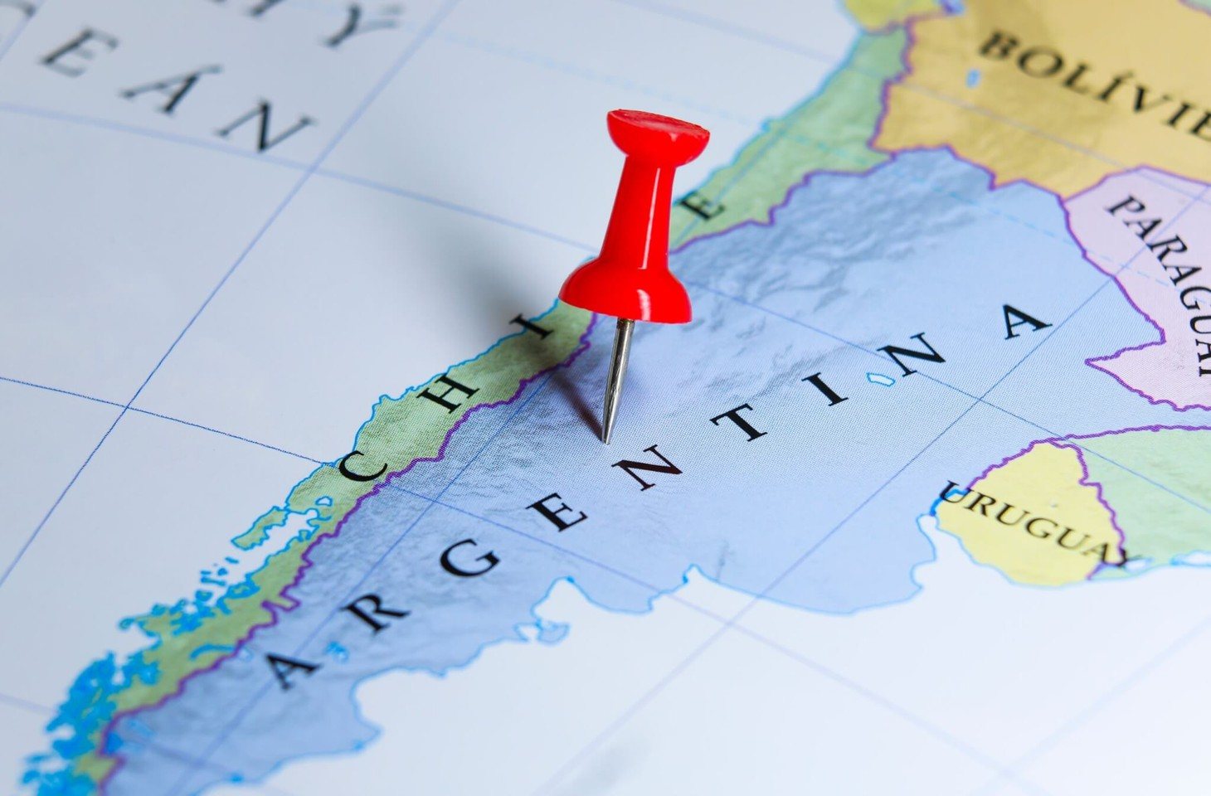
Cascia Gases launches services for divested Linde-Praxair clients

Cascia Gases has begun delivering to customers gained in the mandatory divestment of the Linde-Praxair merger in Argentina.

The company launched its service on 2nd December, having taken control of customers and assets of the divestment ordered by the Argentine antitrust regulator CNDC.
With an aim to ‘restore and promote competition in the industrial gases sector’ in the country, the firm has acquired more than 120 medical and industrial oxygen customers located in several regions, and a 15-year liquid oxygen (LOx) supply contract for up to 75 tonnes per day.

This includes assets (cryogenic tanks and cylinders), two cryogenic tankers and three sites.
‘With the new acquisition, Cascia Gases becomes an important player with nationwide presence in the industrial and medical gases market in Argentina,” stated the company.
Praxair and Linde announced the completion of their $90bn mega-merger in October 2018, two years after the prospect was first announced.

This prompted Argentina’s Secretariat of Commerce to impose new conditions on the merger, designed to encourage the entry of new competitors into the country’s liquid oxygen market.
The conditions were introduced following recommendation from the CNDC after it was found to infringe upon Section 8 of the Defence of Competition (LDC, for its acronym in Spanish) by ‘diminishing, restricting or distorting competition in a way that may result in harm to the general economic interest.’

An investigation by the CNDC found that the Linde-Praxair merger would concentrate over half of Argentina’s liquid oxygen (LOx) production capacity, risking market dominance and negatively impacting oxygen and other gas sales.

Most LOx suppliers rely on Linde or Praxair for gas, leaving competitors vulnerable to restricted supply or price hikes. Oxygen accounts for 60% of Argentina’s traded gases by volume, making it the most sold gas in the country.

Recourse：gasworld

